{{CustomerName}}
{{FullAddress}}

FAO: {{ContactName}}

{{TodaysDate}}

Our Ref: {{ProjectName}}

Dear {{ContactName}},

We would like to thank you for your recent valued enquiry.

We have now reviewed the information and take pleasure in providing the following proposal for your consideration.

Should you require any further assistance, please do not hesitate to contact us.

Yours faithfully,
{{ConsultantName}}

Consultancy Services



Consultancy Services

Scope of Works

Project name: {{ProjectName}}
Data Centre Advanced Health Check Audit
Date: {{TodaysDate}}
Customer: {{CustomerName}}

Contents
1. Introduction 4
2. Audit Aim 4
3. Areas Assessed 4
4. Breakdown of Assessment Areas 5
5. Test Equipment 6
6. Audit Report 6
7. Customer Benefits 8
8. Price Schedule 9
9. Commercial Details 10
10. Further Information 11

1. Introduction
The Health-Check is designed as a non-intrusive site level audit service aimed to identify specific problems in data rooms and Data Centre’s. The audit provides a deep dive into all operational system levels incorporating White & Grey Space environments, Power Distribution, Uninterruptible Power Supplies (UPS), Cooling Infrastructure, Airflow Management, Monitoring, Rack configurations, containment systems and Generators. On request a Straight-Line Diagram (SLD) Analysis and validation can be undertaken.
Our Accredited Data Centre Consultants will identify the main pain points of the facility, tailor a detailed measurement and analysis plan for the necessary system levels creating an accurate overview of the overall data centre performance. The collected information is translated to Identify any Single Point of Failures (SPOF), operational issues, infrastructure health status and Individual equipment performance analysis.
Once Data Centre Health-Check Audit has been undertaken, our consultancy experts will take the key recommendations provided and turn them into a constructive and practical action plan through detailed reports backed by the on-site measurements to support you in achieving your energy efficiency goals and ensure the highest power availability for facility and business continuity.

2. Audit Aim
The assessment is designed to provide a customer with the following end products:
- Identify observations and areas of concern across the data centre and the key operating environments
- Evaluate the design and operational processes against regulations, standards, and recognised industry best practices.
- Identification of Single Points of Failure (SPOF) and operational risks
- Identification of energy saving and operational expenditure (OPEX) savings
- Conclusion and summary of audit findings with supporting evidence from on-site measurements, photographs, and Thermal images
- Forward recommendations designed to address the identified areas of concern and operational improvements to allow a customer to formulate an Action Plan

3. Areas Assessed
As highlighted, this is a non-intrusive assessment and incorporates the following:
- Physical Layout of the data centre
- Rack configuration and management
- Power Distribution incoming feed to IT Power Distribution Units (PDUs)
- Airflow Distribution & Management
- Cooling architecture
- Building Management Systems (BMS)
- Cross reference to potential Tier classification
- Evaluation and validation of Straight-Line Diagram (SLD) if requested
The audit will be completed within 2-3 working days, subject to the size and complexity of the given data centre.

4. Breakdown of Assessment Areas
The breakdown of the audit areas but it should be noted that this will vary from data centre to data centre subject to the physical layout, building and system architectures. Subsequently, the audit and report will be tailored to the given data centre and supporting environments:
Physical Layout | - Labelling, floorplans, and documentation  - Operational risks and areas of concern  - The condition of a raised access floor  - Floor loading capacities  - Quality of supply and return plenums  - Lighting quality (Lux rating)  - Wasted whitespace potential  - Service penetrations into the whitespace  - Fire protection systems & firestop practices  - Access Security & Emergency Exit
Rack configuration & management | - Power distribution to the cabinet (including earthing)  - Effective use of power at cabinet level  - Airflow to cabinet and across the IT equipment  - Quality of cabling and patching  - Identification of bypass and recirculation within rack  - Data cable infrastructure & containment checks  - Cold/Hot aisle containment checks (if applicable)  - Resilience and availability  - Environmental monitoring  - Identification of redundant cabling & equipment  - Rack identification and warning labels  - Whitespace cleanliness against ISO 14644-1
Power Distribution | - Transformer or Utility point of demarcation  - Main Switchboard checks  - Uninterruptible Power Supply (UPS) and battery checks  - Review battery monitoring system  - Evaluation of UPS efficiency  - Power Distribution Units (PDUs) and/or Distribution Panels (DPs)  - Remote Power Panels (RPPs) – if applicable  - Rack Power Distribution  - Calculation of the Power Usage Effectiveness (PUE)  - Power cable distribution & containment checks  - Generator rating checks  - Labelling and warning signage  - Review of maintenance documentation  - End of Lifecycle (EOL) review
Cooling Architecture | - CRAC Airflow rates (m³/h) – supply & return  - Floor plenum pressure (positive and negative)  - Air replenishment supply readings  - Outside Heat Exchanger (OHE) checks  - Chiller Unit checks  - End of Lifecycle (EOL) review
Airflow distribution & management | - Cabinet Supply and Return Air Temperatures (SAT & RAT) measurements  - Relative humidity (RH) and Dew Point measurements  - Delta T across the IT equipment  - Vented tile and floor pressure readings  - Identification of bypass & recirculation  - Review environmental monitoring systems (if applicable)  - Computational Fluid Dynamics (CFD) analysis
BMS & monitoring systems | - Review of alarms and monitoring systems  - Review of environmental internal/external monitoring  - Review of on-site BMS data (if applicable)
Tier classification (Upon request) | - Review of the SLD against customer design specification  - Review of resilience and redundancy levels  - Validation of design architecture versus projected Uptime Institute Tier classifications
Table 1: Breakdown of Assessment Areas

5. Test Equipment
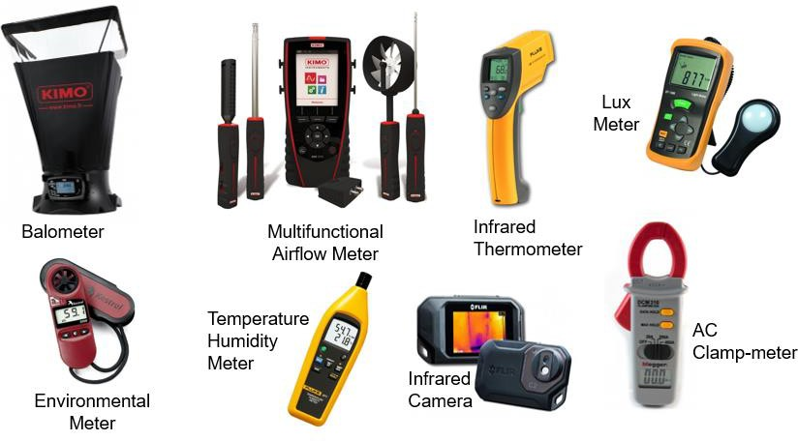
All test equipment is industry approved and fully calibrated, all calibration details will be highlighted within the assessment report.
Figure 1: Assessment Equipment

6. Audit Report
The report will provide detailed data analysis of problems and issues highlighted during the assessment, with the identified areas of concern broken down as follows:
- Breakdown of assessment data to precisely understand the areas of concern
- Evaluation of operational and business requirements
- Identification energy efficiency and operational expenditure (OPEX) savings
- Single point of failure (SPOF) and operational risk analysis
- Identification of inefficient and obsolete equipment
- Identification of safety and poor working practices
- Status of the original design versus the present and future customer demands
- Recommendations and solutions

The overall aim of the report is to provide a customer with the technical structure to establish a comprehensive action plan to resolve the identified areas of concern. The report will be delivered against the agreed audit scope and formulated from accurate collated data and not assumptions. All observations and conclusions will be supported by appropriate technical evidence utilising photo’s, test result and evaluation tables. The report will be formatted covering:
- The audit scope
- Executive summary
- Audit breakdown/overview
- Audit Assessment (areas audited)
- Observations
- Conclusions
- Recommendations
- Appendices and Tables
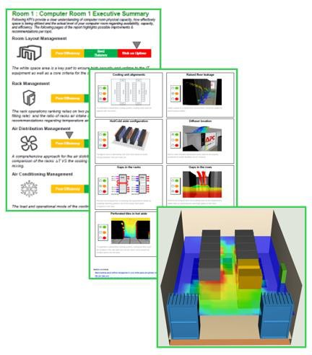
Figure 2: Report Extraction Examples

7. Customer Benefits
The Health-Check Audit will provide Customers with a clear understanding of the operational status and design maturity of their designated data centre. Key benefits including:
- Detection of opportunities for:
- Improving Cooling performance
- Optimising Airflow Management
- Increasing Power supply reliability
- Identification of stranded, space, power and/or cooling
- Identifying Physical layout risks
- Identification of inefficient or obsolete equipment
- Evaluation of Rack Space management
- Reduced risk of operational downtime
- Improved Return on Investment (ROI) capability
- Identification of Asset Lifecycle
- Improved Data Centre Longevity
- Improved Energy Efficiency opportunities
- Improved working practices
- Future Sustainability Improvements
- Productivity & Procedural Improvements
- Turning Opportunities into Practical Action Plan
- Turning Plans into Reality through Design and Specifications

8. Price Schedule
Item | Work Description | Price
1 | Place Holder | Placeholder
Total (ex. VAT)

The fee includes all correspondence, meetings, and document reviews pertinent to complete summary report and audit compliance.
Please note: All fees presented are for the pre-defined scope of works, any additional requirements or changes in scope can be met by mutual agreement with the opportunity to revise costs and timescales proportionally.

9. Commercial Details
Validity | Our offer is open for acceptance for 60 days from the date of this quotation ref {{ProjectName}}
Delivery | Based on our present knowledge of availability of personnel and our current programme, we estimate work commencement to be typically 4 working weeks after placement of order and receipt of all information requested in this quotation.  However, should this period be outside your requirements, we would be happy to discuss your needs in more detail.
Order | We would require an official purchase order related to and referencing this proposal. Please send orders to the address and Bid Engineer detailed on the front page of this quotation. A copy of the order should also be emailed to the Bid Engineer.  To be processed without delay your order should include the following information:  - A valid Purchase Order  - Our reference – {{ProjectName}}  - Agreed price  - Formal acceptance of Schneider Electric’s general conditions of sale
Payment Terms | The price(s) quoted are based on the following Payment Terms  - {{PaymentTerms}}  Important Notes:  It is assumed that the project would be completed within 8 weeks of receiving a valid purchase order. Should the project not be completed within this period, we reserve the right to invoice the work completed to that date and review the price of the remaining work according to the newly agreed timescale  Payment Terms offered are subject to satisfactory findings of our routine credit status check.  We understand that the above payments are not subject to any retention.
Conditions | Our offer is made in accordance with Schneider Electric Terms & Conditions UK & Ireland, a copy of which is available upon request or can be found at:  http://www.schneider-electric.co.uk/documents/general/legal-information/Schneider-Electric-Conditions-of-Sale.pdf#page=1  However, we confirm we are prepared to discuss mutually acceptable terms and conditions prior to any contract award should the Schneider terms prove unacceptable.

10. Further Information
Basis of Offer | - Our offer is based on the following requirements.  - Our working requirements.  - Normal working hours would be between 08:00 and 17:00 weekdays and excludes Bank Holidays. Any hours to be worked outside of these times would be charged extra.  - On shore working.  - Unrestricted access to site as and when required (accompanied)  - Work can continue uninterrupted without delays by other parties.  - Unless otherwise stated all work is office based. Site visits and attendance at meetings would be a chargeable addition based on our standard rates.  - Unless a survey has been carried out by Schneider Electric all work is based on information provided to us. We accept no liability for the accuracy or validity of this information how so ever provided.  - Any required changes to the work as a result of inaccurate or invalid information would be a chargeable addition based on our standard rates.
Not Included in Our Offer | We have not included for any of the following:  - Installation of any equipment.  - Commissioning of any equipment  - Attendance at any meetings unless otherwise stated in the scope of works
Standards | Schneider Electric Ltd complies with and works within the following standards:  - ISO14001  - ISO9001  - The Management of Health and Safety at Work Regulations.  - Health and Safety at Work Act.  - BS7671:2008 Requirements for Electrical Installation  - The Provision and Use of Work Equipment Regulations.

